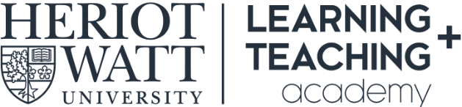

Getting Ready for AY21-22: A Record of Teaching Team Actions
This template is to help record discussions and action points as you work through the Getting Ready for AY21-22: Teaching Team Conversations Guide.

Course Code: Course Title: Course Leader(s):
Preparation | Discussion Points | Actions | Complete?
Getting Started:
Ensure that your Course Team has completed Canvas Fundamentals 1 & 2 training and refresh engagement with the Introducing Responsive Blended Learning module.

Question 1:
How can you strengthen your course team, build collegiality, and work across campuses?

Question 2
How will you integrate the move to Canvas into your preparation for AY21-22 and ensure your Course site is engaging, easy to navigate and supports student learning?

Question 3:
What aspects of your course design for RBL would benefit from further enhancement?

Question 4:
How will you support students whose learning has been disrupted over the past two years?

Question 5:
Identify the key assessments in your course and consider how they could be adapted for remote delivery and submission.

Question 6:
What will you practically do to support students who are on campus and those who are studying at a distance?

Question 7:
Identify possible options for any practice-based learning that needs to take place in specialist spaces and / or any work-based learning elements.

Question 8:
Consider how you will ensure your course is accessible for all of your students.

