Before the session, please skim read the table in Section B (p2) and ONE of the four case studies in Section C (pp3-9). You will need this handout during the session.
Engaging students in learning:
Making my teaching sessions more active

Mick Healey and Ruth Healey
Healey HE Consultants
mhealey@glos.ac.uk; r.healey@chester.ac.uk; www.mickhealey.co.uk

Presentation at Heriot Watt
Tuesday 9 June 2020
08:45 for 09.00 start (Edinburgh), 11:45 for 12.00 start (Dubai), and 15:45 for 16.00 start (Kuala Lumpur)
We ask that you log in at least 15 mins before the session is due to start for some important pre-session activities. The session has been designed to last a maximum 1.25 hours. It will be followed 15 minutes later by an informal discussion session lasting about half-an-hour.

- Unpacking active learning

- “Active learning is any teaching method that gets students actively involved.” (Keyser 2000, 35)

- Active learning is defined as any strategy “that involves students in doing things and thinking about the things they are doing.” (Bonwell & Eison 1991, 2)

- BUT “Student activity does not itself imply that learning will take place.” (Ramsden 2003, 113)

- “It is not enough just to do, and neither is it enough just to think. Nor is it enough simply to do and think. Learning from experience must involve linking the doing and the thinking.” (Gibbs 1988, 9)

- "Good practice uses active learning techniques. Learning is not a spectator sport. Students do not learn much just sitting in classes listening to teachers, memorizing pre-packaged assignments, and spitting out answers. They must talk about what they are learning, write reflectively about it, relate it to past experiences, and apply it to their daily lives. They must make what they learn part of themselves.” (Chickering & Gamson 1987, 3)

For a 5 min video from MIT introducing active learning see: https://www.youtube.com/watch?v=zoa2pKYp_fk

Phil Race’s (2014) ‘Ripples model’ of student learning

This focuses on seven factors which encourage quality learning (Table 1).

Table 1 Evaluating Active Learning Practices through Race’s Seven Factors underpinning Quality Learning

Wanting to learn: How are students motivated/ interested / enthused by this practice?

Needing to learn: Why would they put in some hard work to learn from this practice?

Learning by doing: What are the opportunities for students to practice / learn by mistakes?
- Making sense of what has been learned (digesting): What are the opportunities for students to get their heads round what they have learnt?
- Getting feedback on how learning is going: How do students obtain reactions / comments from other people (e.g. students, tutors) about what they have learnt?

Getting students to deepen their learning by coaching other students: explaining things to each other.
- Allowing students to further deepen their learning by assessing their own learning, and assessing others’ learning: making informed judgements

For each of the practices you may like to ask: “How do the students engage with each of these factors”?
Not all the factors should necessarily be included in every practice. Some will be implicit rather than explicit and some will be covered elsewhere in the course. However, in some cases adding an opportunity for students to engage with the factor explicitly may enhance the quality of the learning.
- Short activities to engage students in learning within a session

As you read each example, put a), b) or c) in the final column, according to whether you have:
a) Tried using this activity
b) Experienced this activity, but not tried it yourself
c) Neither experienced, nor tried this activity

1. | Brainstorming | Everyone thinks of as many different ideas as possible. All ideas are accepted and recorded without comment. The ideas are evaluated after a set time period or when the inspiration ends.
2. | Case studies | A story or scenario is presented to the group (often, but not always) as a handout. Groups discuss the story or work together on questions.
3. | Critical incidents | These are brief written or spoken depictions of vividly remembered events. These can be used during class to bring out those ‘aha’ moments which had a real impact on their learning, or can be used about difficult concepts. Get the students to write a description (where and when it occurred), think about what was involved (e.g. a topic or problem...) and then unpack why it was so memorable.
4. | Exit ticket | At the end of a lecture get students to write an exit ticket which responds to the question “What questions remain after today’s session?” and hand in on the way out. Collect any written responses and address them in the following session.
5. | Jenkins Line | Named after Alan Jenkins (Geographer/Higher Educationalist). When a topic has polar opposites or a spectrum of possible answers or viewpoints, get students to place themselves along a line and discuss their position with their neighbours, and possibly be called upon to discuss/justify their position with the class. Why are you standing there?
6. | Jigsaw | Allocate students into groups of 4-6 (ideally the same number in each group). Divide your content into the same number of topics as you have group members. Each student is the ‘expert’ on one topic; have experts in the area get together first, so they become more expert, then return to the broader group where each one is the expert. Each then has to teach the rest of the group their topic and answer Qs about it. Research has shown that we learn more by teaching it. https://www.youtube.com/watch?v=euhtXUgBEts
7. | Mind maps | A topic is written on the board or on a flip chart. The class/group suggests and organizes ideas and information, presenting them visually, often in clusters. Can be carried out using a large group on one diagram, or in smaller groups, or individually.
8. | Quick quiz | During a class have a quick quiz on the material just covered. This could also take the form of a problem-solving exercise (or practice exam questions) and groups or individuals can compete for speed and accuracy.
9. | Round | Every person takes a turn to make a statement. Useful topics:  - One thing I need to know about …  - Something I learned today …  - One important point (about the topic) …
10. | Think-pair-share | Each person considers the topic/question and writes down some ideas/answers. S/he joins with one other for discussion. This provides a good basis for wider discussion and answers tend to be much more forthcoming in a plenary.

Source: This table is based on a longer version compiled by Rachel Spronken-Smith (Otago) in 2011 from many sources and covers a range of possible activities to promote engagement and active learning in a variety of situations.

- Examples of activities lasting one or more sessions

In this section four case study examples are presented of: the inverse or flipped classroom; inquiry based learning; learning through debate; and learning through a World Café format.

1. The inverse or flipped classroom
An increasingly popular way in which active learning is becoming embedded in courses is through the development of inverse or flipped classrooms, in which students obtain the material traditionally covered in lectures prior to the class through, for example, readings and videos and sometimes using open educational resources, such as MOOCs, and then spend the time in class (whether face-to-face or online) in discussion, problem solving and other experiential activities. Ideally the students then undertake some follow-up activities. Student evaluations of teaching show that students rated the instructor significantly higher in a flipped classroom setting compared to a lecture format (Samuel 2019). The key to the flipped classroom experience is the linkage between the out-of-class and in-class activities. Karanicolas et al. (2015) outline 7 steps to flipping (Fig 1).

Fig. 7 Seven Steps to Flipping with a Framework
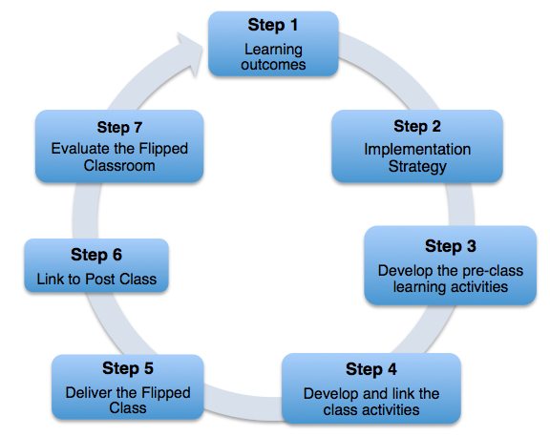
Source: Karanicolas, Snelling and Winning., 2015; http://www.adelaide.edu.au/flipped-classroom/about/

An example of the application of the flipped classroom
“McLaughlin, Roth and Glatt (2014), with pharmaceutical students, adopted a version of the flipped classroom where they off-loaded content for students to learn on their own and devoted class time to engaging students in student -centred learning activities. Adopting a student-centred and flipped approach improved attendance and learning. Students perceived the value of the approach to their learning, with 85% (n=126) of students favouring the flipped learning experience over traditional lecture formats by the end of the course. Key elements in this approach include student responsibility to come to class with an understanding of the material in order to be able to fully participate in the learning and teaching experience and the use of appropriate assessment. The use of online videos prior to sessions, team work, formative assessment using clicker/audience response questions, and explicit instruction from the lecturer to focus learning using micro-lectures (one to three minutes in length); varied modes of summative assessment (student presentations, quizzes, examinations, projects; online reflective questions and answers) were all integral elements of their approach” (King et al., 2015, 27).

For another example of the application of a flipped classroom see Scale Up at Nottingham Trent University.

2. Inquiry based learning (IBL)
We are using the term IBL as a generic term in which students learn through various forms of inquiry, including problem based learning, team based learning, research based learning, challenge based learning, community based learning and case based learning. The main components of IBL are illustrated in Fig. 2. The focus of the activity may be on one or two or these components (e.g. identifying a research question or collecting and analysing information), but we argue that students should be taken right through the process at least once a year and not leave it until the final year project or dissertation. IBL may be used as an alternative to attending a lecture, for students to learn about existing knowledge which is new to them. It may also be used for students to undertake research, where they are creating new knowledge for society (Levy and Petrulis, 2012).

Fig. 2 The Inquiry Process (from Justice et al. 2007)
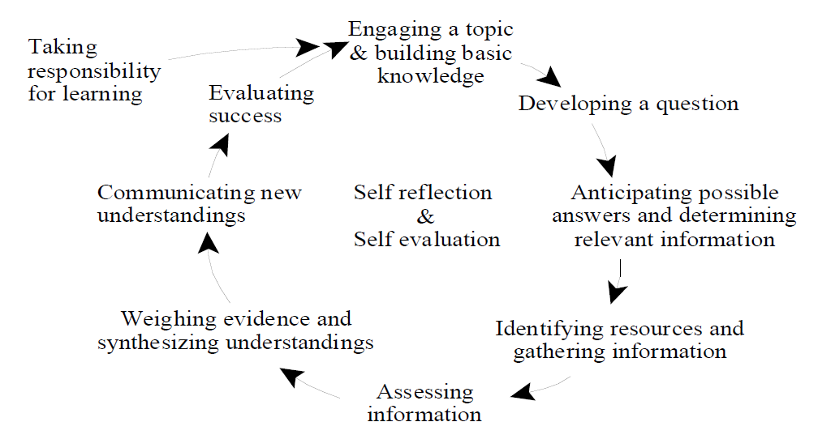.
Inquiry-based learning introductory course for social sciences had a significant impact on students’ subsequent performance at McMaster University, Canada
McMaster University has been running a first-year course for social sciences based on inquiry since the late 1990s. This case study discusses this award-winning course as it evolved over the first five years (see Justice et al. 2002; 2007a), since then other instructors have taken on the course and is taught to reflect their interests. It is typically taught in groups of no more than 25 students assigned to an instructor. All of the groups have the same curriculum, reading material, process of assessment, and goals that are outlined in a detailed compendium. The classes meet for 12 three-hour concurrent sessions. Class time consists of a combination of exercises and tasks for building the students’ critical abilities and time for students to share ideas about their individual inquiries with other students. Much of class time involves groups of four or five students assisting each other in such things as clarifying understandings or planning research strategies.

All students investigate aspects of a broad social science theme, such as ‘self identity’ and addressed a common inquiry question, such as: ‘Why do images of ethnicity, race, gender, sexuality, age, class, or abilities help to create aspects of personal and community identity?’ Students have to propose their own inquiry question, such as: ‘Why do some children apparently become violent after watching violent cartoons while others seem to be unaffected?’ They have to justify why the question is important in relation to existing literature. They then investigate the question through a process which involved developing and testing hypotheses using secondary sources. The course emphasizes the development of skills, including critical reading and thinking, independent and collaborative learning, information searching and evaluation, analysis and synthesis, oral and written communication, and self and peer evaluation.

Analysis of five years of data (Justice et al., 2007b), comparing students who took the Inquiry course with comparable students who did not, shows that it has had a significant impact on how well students perform during their academic careers. The findings allow for initial differences between the two samples. Taking the Inquiry course is associated with statistically significant positive differences in obtaining passing grades, achieving Honours, staying on the Dean’s honour list, and remaining in university.

Recent research investigated in what way(s) Inquiry 1SS3 students changed that might explain their long-term enhanced performance at university. A quasi-experimental study compares a randomly selected group of 54 students who took Inquiry 1SS3 in their first semester with 71 comparable students who did not (Justice et al., 2009a, b). The research goes beyond self-reports of learning and directly measures abilities and performance. Inquiry 1SS3 is associated with meaningfully higher scores in actual performance tests of many intellectual and academic skills and often the magnitude and significance of the difference between groups is comparable to that between upper- and lower-level students (~2 years of university).
Sources: Justice et al. (2002, 2007a and b; 2009a, b; see also: http://www.youtube.com/watch?v=i9idE_uCIpc

For numerous mini case studies of undergraduate research and inquiry in different disciplines and countries from first year to final year and across programmes see: Healey and Jenkins (2009) and the 150pp handout under resources on our website www.mickhealey.co.uk.

3. Learning through debate

Many controversial subjects characterize the 21st century which are addressed across different disciplines. Issues such as climate change, sustainability and social exclusion generate much discussion and often involve clear differences in opinion of how they might be addressed. Higher education is an important space for critical engagement with challenging issues. Consequently, undergraduates should be able to analyse critically the evidence on topics related to their degree from several different perspectives and be able to express their opinions on how these issues should be tackled orally as well as in writing. A debate is one such learning experience.

A debate is defined as a formal discussion about an issue or a problem (Thomas, 1996). Debates are distinct as an active, argument form of oral pedagogy, which can bring drama to the classroom and engage students in lively discussion. The method makes it necessary for students to seek reasons to justify their viewpoint by developing such abilities as identifying value assumptions within arguments and judging whether data are misleading or absent (Green & Klug, 1990). This pushes students to evaluate critically the evidence on either side of a debate and creatively build counter-arguments. Historically debates have an oral tradition, although Web 2.0 technologies have the potential also to create a space for online debate in a written format (Selwyn, 2007), or virtual debates via Second Life, Skype, Teams, Zoom etc.

The right of asylum seekers to work in the UK debate, University of Chester, UK
This debate was initially an unassessed exercise as part of a third-year undergraduate degree module entitled: ‘Excluded Peoples? Migrants and refugees’. However, following feedback from students it became an assessed part of the module in 2018. The preparation and the debate runs over two consecutive teaching sessions (four hours), beginning around five weeks into the course. The topic in this exercise was the right of asylum seekers to work in the UK. The students are divided into groups one in support of asylum seekers working in the UK, and one against. Each group are given access to the same ‘starter pack’ of resources online and given the same reading list. They are encouraged to go beyond this information in order to access evidence that their opposing team may not have. The groups are then given around three weeks to prepare their arguments. The debate is run using the schedule in Appendix 1.

As a team, students decide who takes the lead on different sections. You may have one or multiple students involved in each section. Anyone may respond to questions posed by the opposing team. Initially this was a class exercise, but after years of consistent feedback that students wanted this to be assessed we brought in individual assessment against the following criteria:
- Understanding of debate topic
(In the points and counterpoints you make, to what extent do you show an understanding of the topic being discussed? Through your contributions to the debate do you show an understanding of different aspects of the debate topic?)
- Presenting an argument
(To what extent do you present sustained and reasoned arguments during the debate? Do you use evidence to support your arguments?)
- Oral communication
(How clear and confident are you when expressing your points of view during the debate? Do you articulate your contributions well?)
Source: Healey R. L. (2012)

Appendix 1: Debate Structure

Debate Team: | Affirmative: For the topic (for asylum seekers working)  Negative: Against the topic (against asylum seekers working)
1. First Affirmative Constructive – 3 minutes
- This is an opportunity for the Affirmative team to speak uninterrupted
- A good introduction that attracts the audience’s attention and interest in the topic
- Clearly state the Affirmative’s position on the topic
- Clearly state the Affirmative’s arguments and support these with reason and evidence
- Conclude effectively
2. Cross Examination of the Affirmative by the Negative – 5 minutes
- This is an opportunity for the Negative team to question what the Affirmative team have introduced
- The Negative team ask questions of the Affirmative team ensuring that the Affirmative team have the opportunity to respond to those questions
- The Negative team should have a strategy or at the very least a direction to their questioning
- New evidence may be introduced to challenge the points made by the Affirmative team
3. First Negative Constructive – 3 minutes
- This is an opportunity for the Negative team to speak uninterrupted.
- A good introduction that attracts the audience’s attention and interest in the topic
- Clearly state the Negative’s position on the topic
- Clearly state the Negative’s arguments and support this with reason and evidence
- Question the Affirmative’s contentions/evidence
- Conclude effectively
4. Cross Examination of the Negative by the Affirmative – 5 minutes
- This is an opportunity for the Affirmative team to question what the Negative team have introduced
- The Affirmative team ask questions of the Negative team ensuring that the Negative team have the opportunity to respond to those questions
- The Affirmative team should have a strategy or at the very least a direction to their questioning
- New evidence may be introduced to challenge the points made by the Negative team
5. Second Affirmative Constructive – 3 minutes
- This is an opportunity for the Affirmative team to speak uninterrupted
- Clearly state each of your contentions - support with reason and evidence
- Respond to Negative arguments/attacks
- Conclude effectively
6. Cross Examination of the Affirmative by the Negative – 5 minutes
- This is an opportunity for the Negative team to question what the Affirmative team have introduced
- The Negative team ask questions of the Affirmative team ensuring that the Affirmative team have the opportunity to respond to those questions
- The Negative team should have a strategy or at the very least a direction to their questioning
- New evidence may be introduced to challenge the points made by the Affirmative team
7. Second Negative Constructive – 3 minutes
- This is an opportunity for the Negative team to speak uninterrupted
- Clearly state each of your contentions - support with reason and evidence
- Respond to Affirmative arguments/attacks
- Conclude effectively
8. Cross Examination of the Negative by the Affirmative – 5 minutes
- This is an opportunity for the Affirmative team to question what the Negative team have introduced
- The Affirmative team ask questions of the Negative team ensuring that the Negative team have the opportunity to respond to those questions
- The Affirmative team should have a strategy or at the very least a direction to their questioning
- New evidence may be introduced to challenge the points made by the Negative team
Rebuttal Speeches – no new arguments – new evidence and analysis are ok
9. Negative Rebuttal – 3 minutes
- Rebuild the Negative case
- Summarize how the Negative position is superior
- Respond to the Affirmative arguments – extend arguments by giving additional support for them
- Conclude effectively
10. Affirmative Rebuttal – 3 minutes
- Rebuild the Affirmative case
- Summarize how the Affirmative position is superior
- Respond to the Negative arguments – extend arguments by giving additional support for them
- Conclude effectively
4. Learning through a World Café format

A ‘World Café’ is an effective way of facilitating discussion and ideas within a large group. It is a good way of providing everyone in a group with the opportunity to share their perspective on a range of different questions around a topic; thereby gaining a wide range of perspectives in a simple but effective way. A World Café operates in three main stages:

- Welcome and explanations: A plenary where the full group is introduced to the format and the focus of the discussion. This includes outlining the guidelines and etiquette of a World Café. The diagram below summarises the key characteristics of the process.
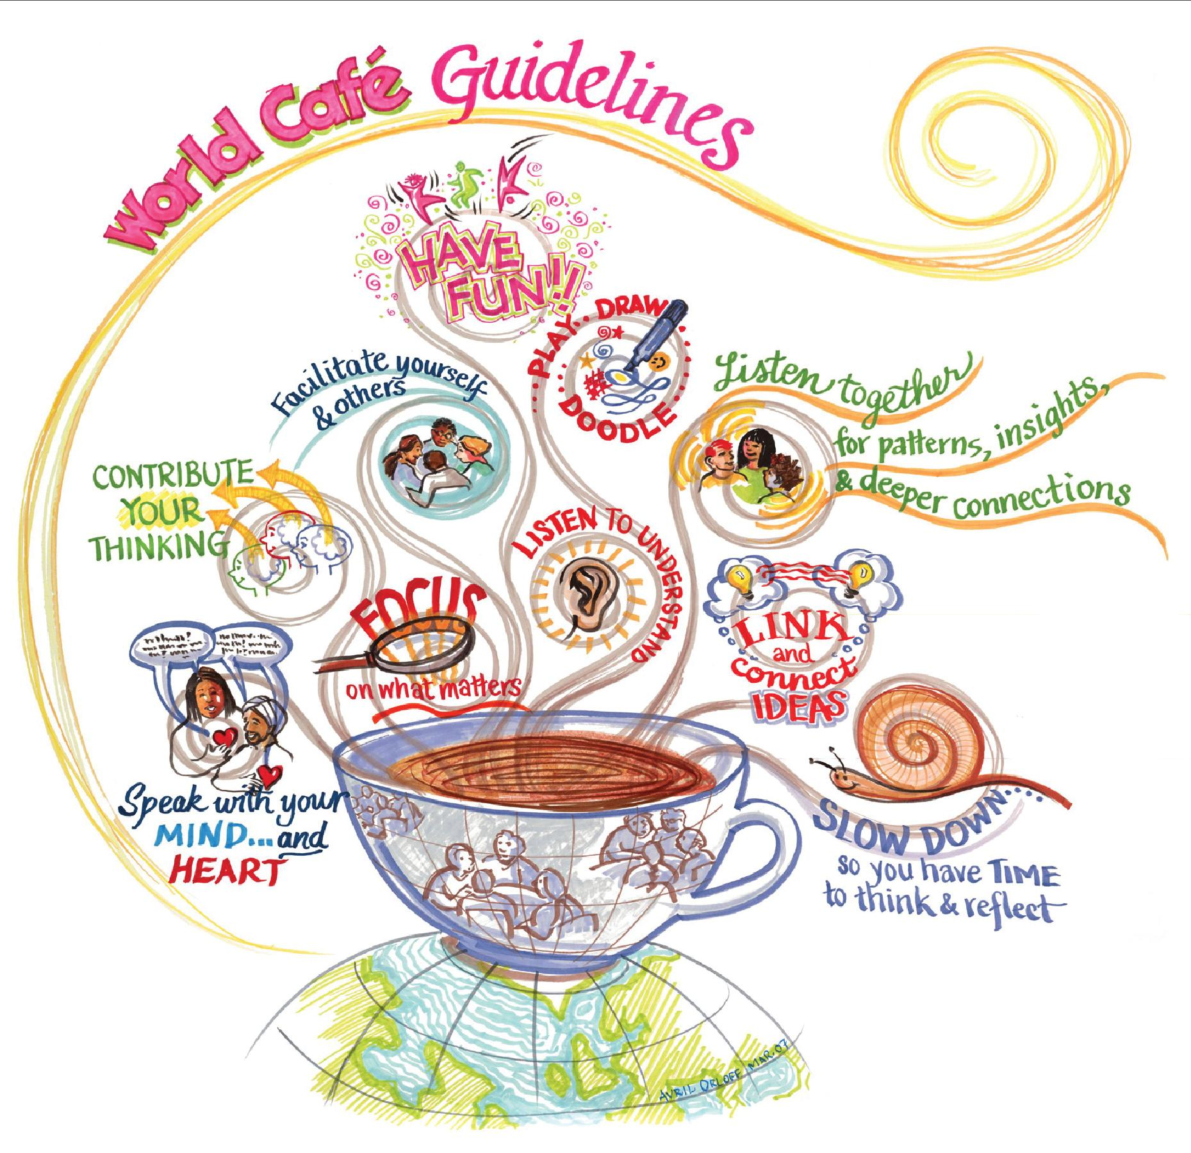
Source: The World Café: http://www.theworldcafe.com/tools-store/hosting-tool-kit/image-bank/guidelines/

- Small group discussion: On separate tables small groups of around 5 people meet to discuss a different question at each table. The total number of tables and questions will vary depending on the size of the group and the number of points for discussion. Each group focus on their first question for around 20 minutes noting down their ideas and thoughts on a piece of paper or paper tablecloth. After the allotted time the whole group moves on to the next table and the next question and the process repeats itself until each group has had the opportunity to discuss each question. Depending upon the purpose of the discussion and the level of detail requested to be included in the written notes it may be necessary or preferable for one person from the previous group to temporarily stay at the table to explain the nature of the previous group’s discussion to the new group at the beginning of each round. Alternatively, each question may have a ‘host’ i.e. one person who stays at that table throughout the discussion session in order to facilitate the discussion and provide the links between the points raised by different groups.
- The harvest of ideas: Returning to plenary after all of the groups have had the opportunity to share their thoughts on all of the questions, now is the opportunity to summarise the responses to each question. If you chose to have a ‘host’ at each table then this is a key role for them. Otherwise the last group for each question should be pre-warned that they will need to summarise the thoughts on the question for the rest of the group. It will likely not be possible to share each point made in relation to each question, so you might keep it to the key messages, or the most significant points, or a 1-minute summary etc; whatever works for the particular topic areas under discussion.

Environment, Poverty & Health Online World Café, University of Chester, UK
This was an online session for a final year geography module for c20 students which was focused on a discussion about the social, political, economic and cultural implications of Covid-19. In preparation for this discussion, the students were asked to read at least two blogs, newspaper articles and writings of geographers, sociologists and philosophers on Covid-19 at:
https://progressivegeographies.com/resources/geographers-sociologists-philosophers-etc-on-covid-19/. The students were sent a written hand out over a week before the session outlining the preparation work and outlining how the session would run online, including detailed instructions of a World Café and how to join the plenary and group discussions.

The session began in plenary on a module specific Microsoft Teams channel were the Tutor talked through the session online with a short PowerPoint which included explaining the technicalities of how they were going to breakup into separate ‘virtual’ tables for the small group rounds. For the small group rounds the students were allocated to a ‘breakout’ room as part of the module specific channel. When they entered this room, they were provided with the link to their first question on a shared One Drive document. Each group made their notes in relation to that question on the One Drive document. After the allotted time, the group were given the link for their next question. This link now contained the question and the notes from the previous group(s) who had already discussed that question. This process was repeated until each of the four groups had discussed the four different questions. For the final question, each group looked at, they were asked to nominate a member from their group to provide a summary of all the notes on the One Drive document to the rest of the class.

During this time, we had two tutors monitoring the discussion groups and moving the groups on to the next question at the appropriate time. These tutors would post the new link and/or ‘pop in’ to each discussion group at the beginning of each round to ensure that the groups were on task and monitored the One Drive documents to ensure that the students understood the task and were populating the documents. It is important that students have the links for all the documents at the beginning of the process to enable a smooth transition between questions in the online format. During the ‘harvest’ the nominated member from each group summarised the discussion for the final question that they looked at. The students who participated were very positive about the experience, particularly as this was one of the first interactive online activities that they had participated in. They noted that they found the experience enjoyable and interesting.

Further information: Ruth Healey (r.healey@chester.ac.uk)

For another example of the use of World Café workshop online listen to this podcast where Jonathan Menary from the Lancaster Environment Centre talks about how he and his team had to transform in-person workshops into virtual workshops at short notice through quick and open thinking. https://digitaleducationpractices.com/2020/04/28/episode-1-transitioning-from-in-person-to-virtual-workshops-without-much-notice/

References

Advance HE Scotland (2019) Thematic Series: Active Learning. https://www.advance-he.ac.uk/scotland/thematic-series/active-learning

Bligh, D. (1998) What’s the Use of Lectures? Exeter: Intellect.
Bonwell, C. and Eison, J. (1991) Active learning: creating excitement in the classroom (ASHE-ERIC Higher Education Report No. 1). Washington, DC: George Washington University.
Chickering, A.W. and Gamson, Z.F. (1987) Seven principles for good practice, AAHE Bulletin 39, 3-7. https://eric.ed.gov/?id=ED282491
Freeman, Scott Sarah L. Eddy, Miles McDonough, Michelle K. Smith, Nnadozie Okoroafor, Hannah (2014) Active learning increases student performance in science, engineering and mathematics, PNAS June 10, 111 (23) 8410-8415
Gibbs, G. (1988) Learning by doing: a guide to teaching and learning methods. London: Further Education Unit. Available: https://www.google.co.uk/url?sa=t&rct=j&q=&esrc=s&source=web&cd=2&ved=2ahUKEwithYKwq4bpAhWAQxUIHf80AW0QFjABegQIARAB&url=https%3A%2F%2Fthoughtsmostlyaboutlearning.files.wordpress.com%2F2015%2F12%2Flearning-by-doing-graham-gibbs.pdf&usg=AOvVaw3cEVglnFWHHNcsE3PDjTPn
Healey, M. (2015) Active Learning and Learning Styles: A selected bibliography. Available at: www.mickhealey.co.uk/resources.
Healey, M and Jenkins, A (2009) Developing undergraduate research and inquiry. York: Higher Education Academy. https://www.advance-he.ac.uk/knowledge-hub/developing-undergraduate-research-and-inquiry
Healey, M. and Jenkins, A. (2018) The role of academic developers in embedding high-impact undergraduate research and inquiry in mainstream higher education: Twenty years’ reflection, International Journal for Academic Development 23(1), 52-64.
Healey, M. and Roberts, J. (eds.) 2004. Engaging students in active learning: case studies in geography, environment and related disciplines, Cheltenham: University of Gloucestershire, Geography Discipline Network and School of Environment. 140pp (ISBN: 1 86174 145 6). https://gdn.glos.ac.uk/active/engagingstudents.pdf
Healey, R. L. (2012) The power of debates? Reflections on their potential for geography in higher education: teaching for social transformation through debate, Journal of Geography in Higher Education 36(2), 239-257.
Justice, C, Warry, W, Cuneo, C, Inglis, S, Miller, S, Rice, J, Sammon, S (2002) A grammar for inquiry: linking goals and methods in a collaboratively taught social sciences inquiry course, The Alan Blizzard Award Paper: The Award Winning Papers, Special Publication of the Society for Teaching and Learning in Higher Education and McGraw-Hill Ryerson, Windsor
Justice, C, Rice, J, Warry, W, Inglis, S, Miller, S and Sammon, S (2007a) Inquiry in higher education: reflections and directions on course design and teaching methods, Innovative Higher Education 31(4), 201-214
Justice, C, Rice, J, Warry, W and Laurie, I (2007b) Taking inquiry makes a difference - a comparative analysis of student learning, Journal of Excellence in College Teaching, 18(1), 57-77
Justice, C, Rice, J, Warry, W (2009) Academic skill development - inquiry seminars can make a difference: evidence from a quasi-experimental study, International Journal for the Scholarship of Teaching and Learning 3(1) http://www.georgiasouthern.edu/ijsotl
Justice, C, Rice, J, Roy, D, Hudspith, B and Jenkins, H (2009) Inquiry and learning to learn in higher education: lessons for introducing inquiry pedagogy into the curriculum, Higher Education 58(6), 841-65
Keyser, M.W. 2000. Active learning and cooperative learning: understanding the difference and using both styles effectively, Research Strategies 17, 35-44.
Levy, P. and Petrulis, R. (2012) How do first-year university students experience inquiry and research, and what are the implications for the practice of inquiry-based learning? Studies in Higher Education 37(1), 85-101.
McLaughlin, Jacqueline E., Roth, Mary T.,; Glatt, Dylan M.; Gharkholonarehe, Nastaran, Davidson, Christopher A., Griffin, LaToya M., Esserman, Denise A., Mumper, Russell J., The Flipped Classroom, Academic Medicine: 89(2), 236-243 doi: 10.1097/ACM.0000000000000086 https://journals.lww.com/academicmedicine/Fulltext/2014/02000/The_Flipped_Classroom__A_Course_Redesign_to_Foster.17.aspx
Race, P. (2014) Making learning happen. London: Routledge (3rd edition). See slides at: https://phil-race.co.uk/2016/04/updated-powerpoint-ripples-model/
Ramsden, P. (2003) Learning to teach in higher education. London: RoutledgeFalmer 2nd edit.
Samuel, Michael L. (2019) Flipped pedagogy and student evaluations of teaching. Active Learning. https://doi.org/10.1177/1469787419855188

