Collaborate Ultra webinar guidance for participants
The course team are looking forward to seeing you at the next webinar.

HOW TO JOIN

Step 1: Make sure you are in a quiet place where you’ll be able to participate in the online session both verbally and via the text chat. A small meeting room or office is ideal for this.

Step 2: Ideally you need a headset with microphone rather than a built-in microphone as this will give best quality audio, however, don’t worry if you don’t have one, you can still participate if you have a built-in microphone or speakers.

Step 3: Collaborate Ultra, our webinar tool, is only supported using Chrome or Safari browsers. Make sure that your browser is up to date.
Join the webinar using one of these or you may not be able to enter the room or hear anything.

You can also download the Blackboard app for iPad/iPhone/Android if you would like to join using a mobile device.

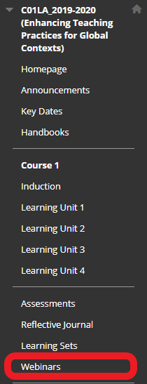

Step 4: Once you’ve opened the course website, click on Tools and then Blackboard Collaborate Ultra.
Alternatively, your menu show the ‘webinar’ link in the left-hand menu on the course website, if so, click on the webinar link.

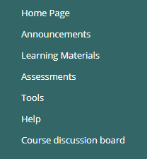

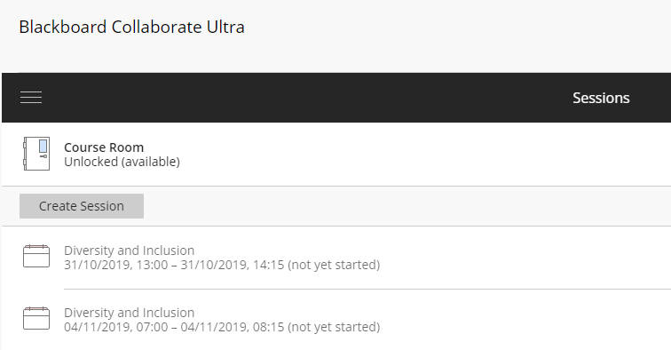
Step 5: Once you have opened Collaborate Ultra click on the link for webinar you wish to join (see fig. 3) Note there may be more than one with the same name so check the date too.

Note: If you join using a link provided by your course team, you will be taken straight to the webinar room.]

ENTERING THE COLLABORATE ULTRA ROOM
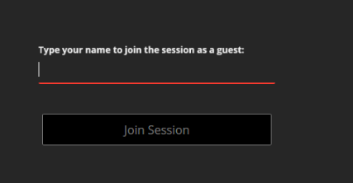
Step 1: When you click on the link to join the room you will be asked to enter your name.

You may wish just to use your first name. Everyone in the room will see what you write so please do not use an unprofessional name if you are not using your own name.

Step 2: Blackboard Collaborate should detect your camera and microphone displaying a pop-up window to confirm which tools to use.

Note: the pop-up window may be different depending on the browser that you are using.

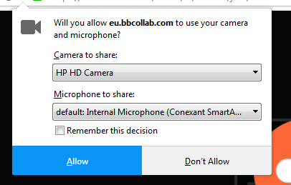
Step 3: Select ‘Allow’ so that Blackboard Collaborate can access your equipment.

AUDIO AND VIDEO TEST
Step 1: If you are having audio or video issues the first thing to do is to check that you’ve got things correctly set up on your computer e.g.
- have you got your volume switched on and your mute off?

- Is your computer connected to the correct headset / webcam? (if you’re using one

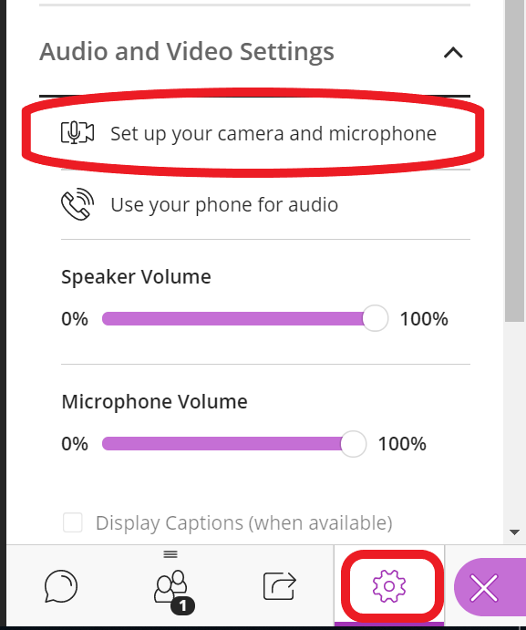

Step 2: If that doesn’t help the you can test your audio and video using the wizard on Collaborate Ultra. Click on the double purple arrow to the lower right-hand side of your screen to open the Collaborate Panel.

Step 3: Click on the ‘cog wheel’ to open the ‘settings’.

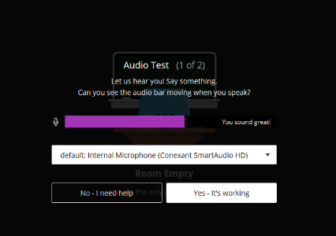
Step 4: Click on ‘set up your camera and microphone’ and then follow the instructions to test, and if necessary, fix your camera and microphone.

If you do not see a pop-up window like this, it may be because your computer does not permit pop-up windows. You will need to enable this before proceeding. You can use your internet search to find instructions line on ‘how to turn off the pop-up window blocker’.

Note: So as not to hold up the session, it is useful to do this at least 15 minutes before the start of the session.

Step 5: If the audio and video wizard does not solve your issues then it may be to do with your computer rather than the room. Try leaving the room and checking your computer audio/video set-up as per step 1 and join again once you are sure they are correct.

PARTICIPATING IN THE SESSION

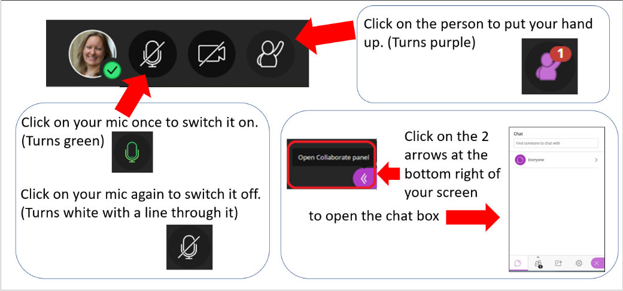
Step 1: Make sure that your audio is switched on by clicking on the microphone.

Step 2: After you have ensured that your microphone works, mute it unless you are speaking.
This is to reduce unnecessary noise during the webinar. You can then unmute when you want to speak.
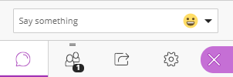
Step 3: If you don’t have a microphone or you cannot speak during the session (e.g. you’re in a public place, you’ve lost your voice etc.), you can use the chat to participate in the session instead.

Feel free to share your thoughts via the mic or the chat.
If there’s silence after you’ve been asked a question, it’s OK just to start talking. It can feel a bit funny at first talking online, but you do get used to it.
Step 4: If you’re worried about interrupting then you can put your hand up.

TOP TIPS
- Remember to keep your microphone muted when you are not speaking, otherwise it can create a distracting audio feedback loop.
- Use headsets rather than external microphone or loudspeakers as they may cause echoes and background noise.
- For big groups, your tutor may decide to disable participants’ audio and / or video to optimise the available bandwidth of the Internet connection.
- If you have a microphone you will get the most out of the session by interacting via the microphone rather than the chat. It’s quicker and you can convey nuances more easily by voice than text.

TROUBLESHOOTING
- Blackboard Collaborate does not detect my camera and/or microphone
Make sure that you have permission to connect external devices to your computer. If you join the Collaborate session from your work computer, some employers may have turned off that permission for your account.
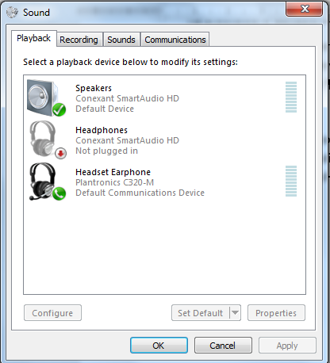

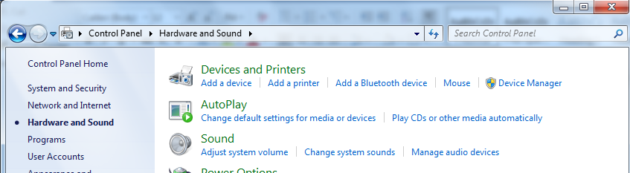
For Windows users: if Collaborate does not detect your headset/headphone/microphone and you have full administration permissions, go to ‘Control Panel’ ->’Hardware and Sound’ ->’Manage audio devices’ and select your audio device as the default choice.

- My computer crashes when opening Blackboard Collaborate
High computer use can cause this, as well as audio issues. Make sure that only necessary programs are running on your computer before starting a Blackboard Collaborate session and close other programmes.

- If you have any other technical issues accessing or joining the webinar then please contact ISHelp@hw.ac.uk.
- Further guidance on the use of Collaborate Ultra (the tool we use for the webinar) is available at https://help.blackboard.com/Collaborate/Ultra/Participant.

