Guidance for participants joining a Teams meeting

How to access the meeting
Click on the ‘Join the online meeting’ link to access the event. You will find this link in the email inviting you to the meeting or by clicking on the meeting shown in your Outlook calendar.
The steps to do this are detailed below.
- Log in to Outlook using a browser
  - go to http://www.office.com and log in using your Heriot-Watt credentials
  - Use the Chrome browser to access Teams, other browsers are not fully supported.
  - This will take you to the Teams page (fig. 1.) where it will ask if you want to open Teams.
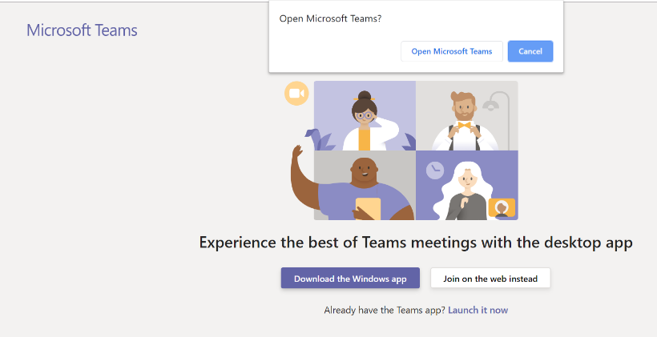
Figure 1 Open Teams
  - Choose to join the meeting in the web version of Teams (unless you have the Teams app already installed on your desktop, phone or tablet and wish to use this instead).
Top Tip: You can join the meeting in advance of the start time if you want to check your access.

- Check your settings and join the meeting
  - Ensure that your video is enabled (unless the meeting organiser has asked you not to use video).
  - Ensure that your microphone is muted until you are ready to speak to avoid interference and feedback.
  - Click on the ‘join now’ button to join the meeting.
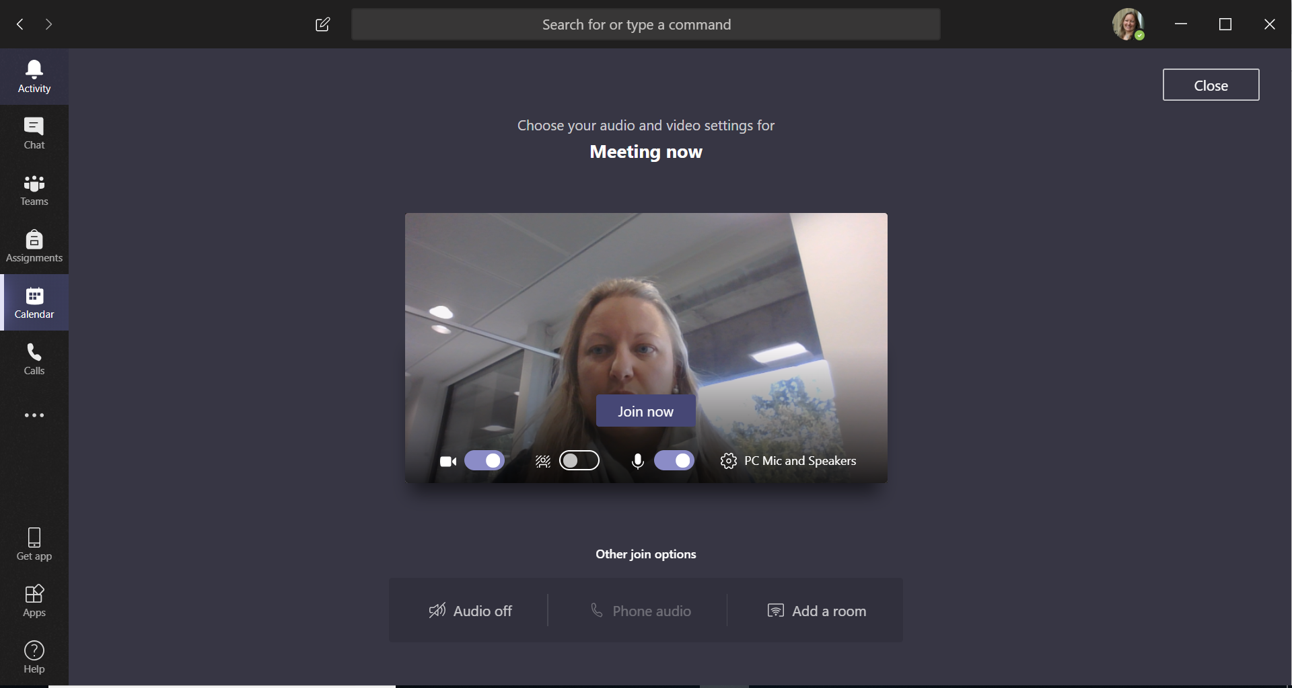
1. Ensure that your video is enabled.
2. Mute your microphone before you join the meeting.
3. Click on the ‘Join now’ button to join the meeting.

Top Tip: If you are using your browser, you may have to allow Teams to use your webcam and microphone.

- During the meeting
Here is a diagram of the settings available to you during a meeting.
Chat
Use this to ask questions and make comments. These will be seen by everyone in the meeting.

Switch audio on / off.
Please keep this OFF until you are speaking.
Switch video on / off.
We recommend having this ON but you may be asked to turn this OFF if connectivity is poor.
Disconnect.
Only use this when you are ready to leave the meeting.

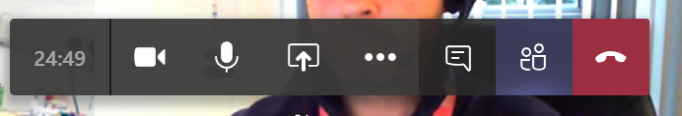

Troubleshooting
- If you have limited bandwidth then you can try switching off video during the meeting as shown on the diagram above.
- Check that you have the correct speakers and mic selected
- Use a headset rather than in-built mic / speakers
If you have issues using Teams contact ISHelp@hw.ac.uk

